**EAC to AppDB migration Plan**

**Pre requites**

1. **Create a dummy ticket number in a sheet for EMEA only apps if required. Else, identify the ticket number to which it has to be migrated to.**
2. **Create a new service name**
3. **Identify the QA lead name for any missed apps**
4. **Add EMEA/AP profiles names ( EMEA & AP) to AppDB**
5. **Flat extract file must be taken from EAC database. This will be used to analyze the current apps data.**

**Other actions:**

1. **Update the Request received date field with the record added date in EAC**
2. **Vendor, pkg id, pkger, command line, GUID, main executable, date will be migrated if available in EAC.**
3. **Some packages will not be found in qadfs and prod stage. Hence no readme.**

**Menu 1:**

**Application Details (Please refer Figure 1)**

**EAC 1.1:**

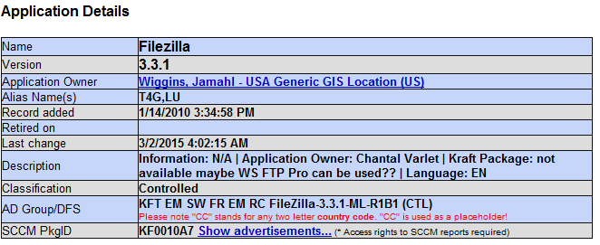

**AppDB Application 1.2:**

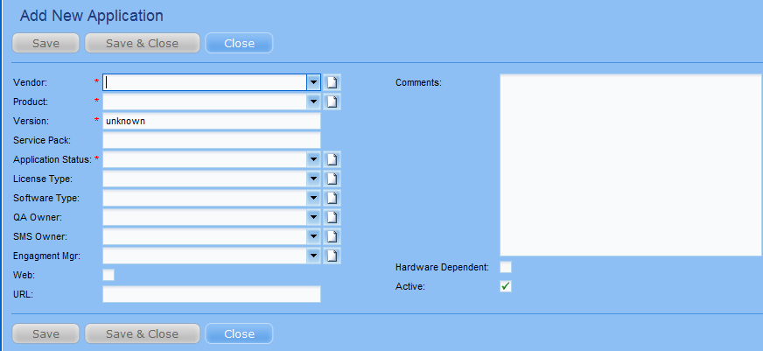

**AppDB packages: 1.3**

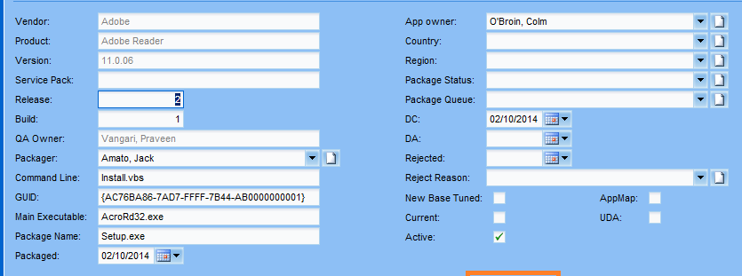

|  |  |  |  |
| --- | --- | --- | --- |
| **Will be Migrated from ( Field in EAC, shown in 1.1)** | **To be migrated to (Field in AppDB, shown in 1.2)** | **Will this be Migrated?** | **Comments** |
| Name | Product | Yes | None |
| Version | Version | Yes | None |
| Application owner. | App Owner in packages | Yes |  |
| Alias Name | - | No | Previously used for alternate name/user friendly name or abbreviated name. Currently used for ASN.  Ex: Name: Citrix metaframe, Alias: Cirix ICA Client |
| Record added | Request received date in Packages | Yes |  |
| Retired on | - | No | Only active applications will be migrated. Anything which is retired will be ignored. |
| Last change | - | No | This is system generated. Cannot be migrated. ( Not needed) |
| Description | Comments in Request page | Yes |  |
| Classification | License Type | Yes |  |
| AD Group/DFS | Comments | Yes | This will be added into comments section along with ASN & count. |
| SCCM PkgID | Comments | No | This field is no more required for reports & hence will not be migrated. |

**Menu 2:**

**W8 status : 2.1**

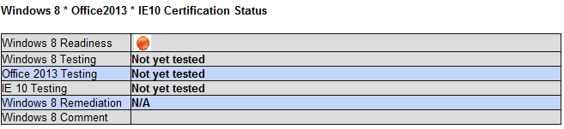

The W8 status of the application will not be tracked as per office 2013 & IE 10 in AppDB. It is tracked by individual profiles as shown in 2.2

Profile Status in AppDB: 2.2

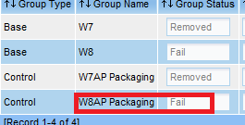

|  |  |  |  |
| --- | --- | --- | --- |
| **Will be Migrated from ( Field in EAC, shown in 1.1)** | **To be migrated to (Field in AppDB, shown in 1.2)** | **Will this be Migrated?** | **Comments** |
| W8 Testing | W8 profiles | Yes | To individual profiles |
| Office 2013 Testing | - | No | Not required |
| IE 10 testing | - | No | Not required |
| W8 Remediation | To W8 base profile | Yes |  |
| W8 comment | To W8 Base profile comment | yes |  |

**Menu 3:**

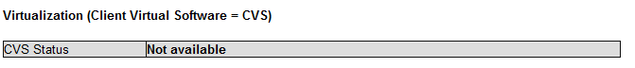

**The CVS status is tracked in ‘CVS mondelez’ profile.**

**3.1**



|  |  |  |  |
| --- | --- | --- | --- |
| **Will be Migrated from ( Field in EAC, shown in 1.1)** | **To be migrated to (Field in AppDB, shown in 1.2)** | **Will this be Migrated?** | **Comments** |
| CVS Status | CVS mondelez profile | Yes |  |

**Menu 4:**

**Details Button**

**4.1**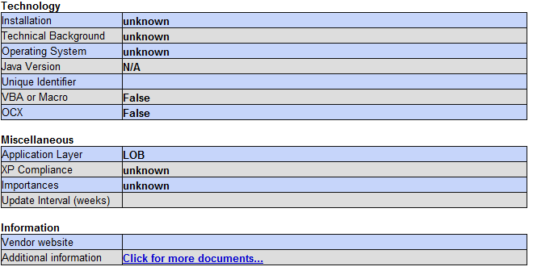

|  |  |  |  |
| --- | --- | --- | --- |
| **Will be Migrated from ( Field in EAC, shown in 1.1)** | **To be migrated to (Field in AppDB, shown in 1.2)** | **Will this be Migrated?** | **Comments** |
| Installation | - | Duplicate | This data is not tracked in the AppDB but same information can be taken from command line field. |
| Technical Background | - | No | This data is not tracked in the AppDB as this data is obsolete |
| Operating system | - | No |  |
| Java Version | - | No |  |
| Unique Identifier | - | No |  |
| VBS or Macro | - | No |  |
| OCX | - | No |  |
| Application layer | - | No |  |
| XP compliance | - | No |  |
| Importances | - | No |  |
| Update Interval( weeks) | - | No |  |
| Vendor website | - | No |  |
| Additional Information | - | No |  |

**Menu 5: Package info:**

**5.1**

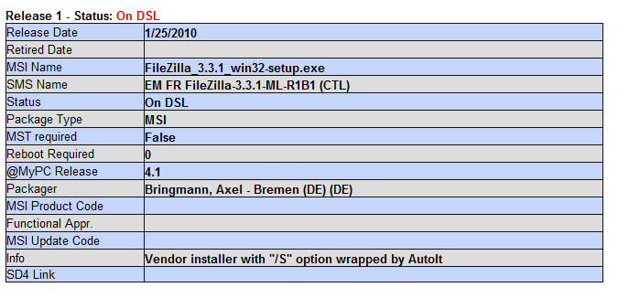

|  |  |  |  |
| --- | --- | --- | --- |
| **Will be Migrated from ( Field in EAC, shown in 1.1)** | **To be migrated to (Field in AppDB, shown in 1.2)** | **Will this be Migrated?** | **Comments** |
| Status: On DSL |  | Duplicate | This data tells us that an application is available in production. The same is updated as PASS in AppDB. Hence this field will be ignored. |
| Release Date | - | No | Data not in AppDB |
| Retired Date | - | No | Only active apps are migrated |
| MSI Name | Package name | Yes |  |
| SMS Name | - | No | This is the advertisement name, same data can be fetched from AD Group. |
| Package Type | - | No | This data can be fetched from the command line entered in AppDB . |
| MST Required | - | No | This data is not tracked in the AppDB as this data is obsolete. Additionally this data can be obtained from command line field. |
| Reboot required | - | No | This data is not tracked in the AppDB as this data is obsolete |
| @My PC Release | - | No | This data is not tracked in the AppDB as this data is obsolete |
| Packager | Packager | Yes |  |
| MSI Product code | - | No | This data is not tracked in the AppDB as this data is obsolete |
| Functional appr | - | No | This data is not tracked in the AppDB as this data is obsolete |
| MSI Update code | - | No | This data is not tracked in the AppDB as this data is obsolete |
| Info | - | No | This data is not tracked in the AppDB as this data is obsolete |
| SD4 Link | - | No | This data is not tracked in the AppDB as this data is obsolete |

**Menu6: Memos:**

**6.1**

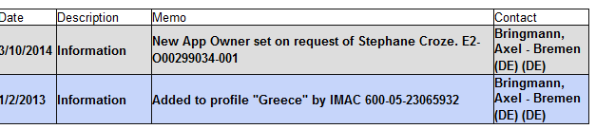

The comments added to this section will be migrated to the comments tab in Packages section of the AppDB. Shown below in 6.2

**6.2**

